**Virtual Machine Links**

VPLE Start of Download - https://www.vulnhub.com/entry/vulnerable-pentesting-lab-environment-1,737/

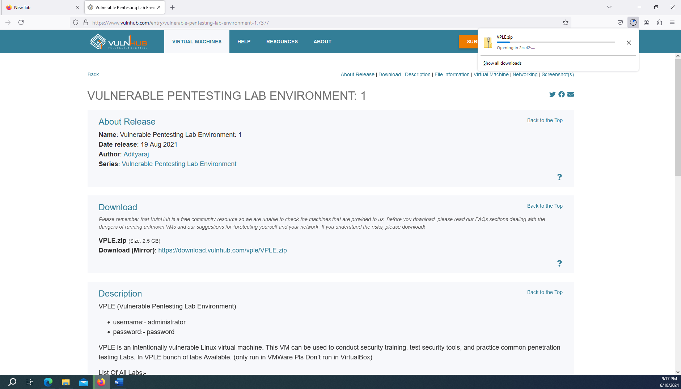

Finished a few mins later with accessible Virtual Box Resources via the VMDK File for virtual box or the VMWare file. The resulting zip file should be extracted using something like 7-Zip

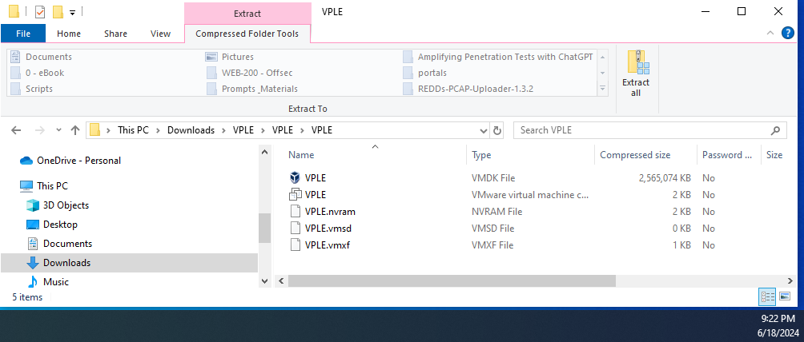

Using VMWare Player as an example, the resource starts successfully and can be interacted with.

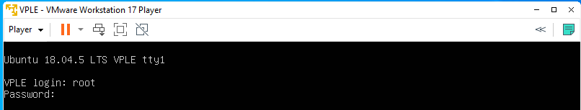

SickOS - <https://www.vulnhub.com/entry/sickos-11,132/>

Resource seems web accessible and would likely produce a similar result as VPLE.

